**Muhammad Harith Bin Zainudin**

**192171**

**Lab Practice 6 (11.10.2016)**

1. The HR needs a report that displays the employee number and the full name of the employees from department Sales. Rename the columns as “Id” and “Names”.

**Answer:**

*select employee_id as "ID", first_name || ' ' || last_name as "Names"*

*from employees*

*natural join departments*

*where department_name like 'Sales'*

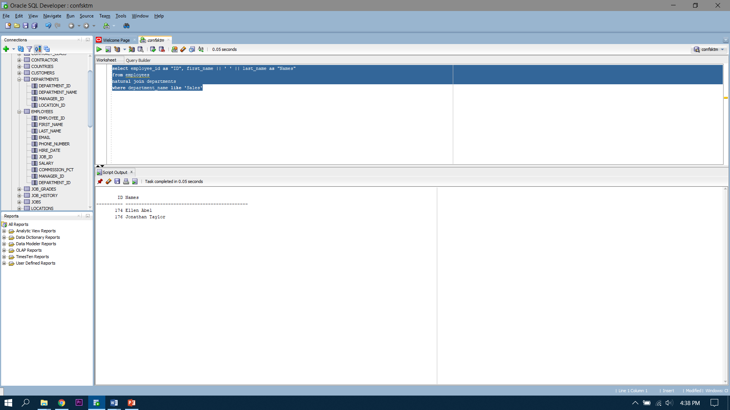

1. Find the list of employees who is not working as sales person and receive salary more than the minimum salary of employee who’s working as Sales Manager.

**Answer:**

*select first_name||' '||last_name "Name", job_id, salary*

*from employees natural join departments*

*where department_name not in ('Sales') and salary > (select min(salary) from employees where job_id like 'SA_MAN')*

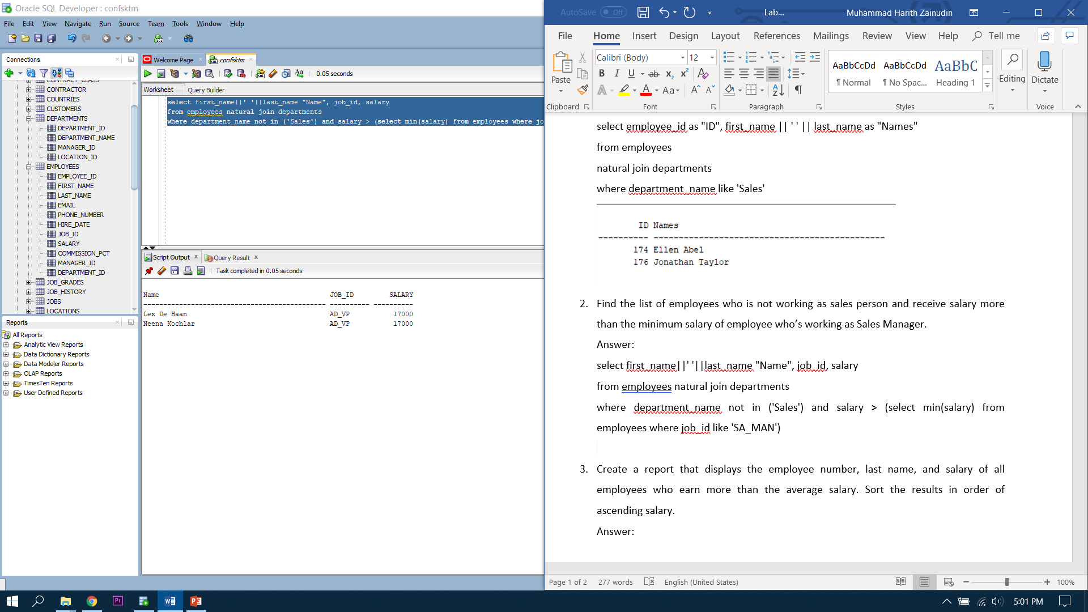

1. Create a report that displays the employee number, last name, and salary of all employees who earn more than the average salary. Sort the results in order of ascending salary.

**Answer:**

*select employee_id, last_name, salary*

*from employees*

*where salary > (select avg(Salary) from employees)*

*order by salary asc*

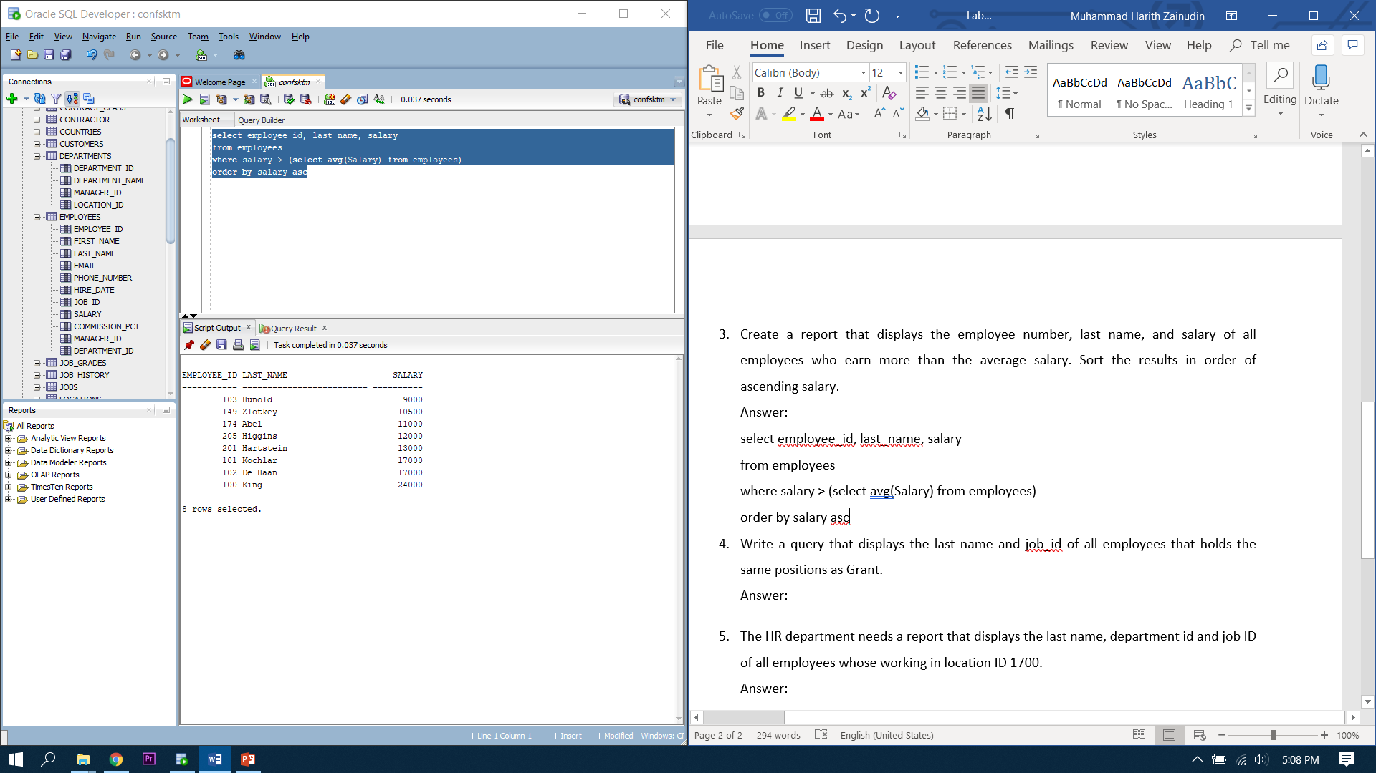

1. Write a query that displays the last name and job_id of all employees that holds the same positions as Grant.

**Answer:**

*select last_name, job_id*

*from employees*

*where job_id=(select job_id from employees where last_name='Grant')*

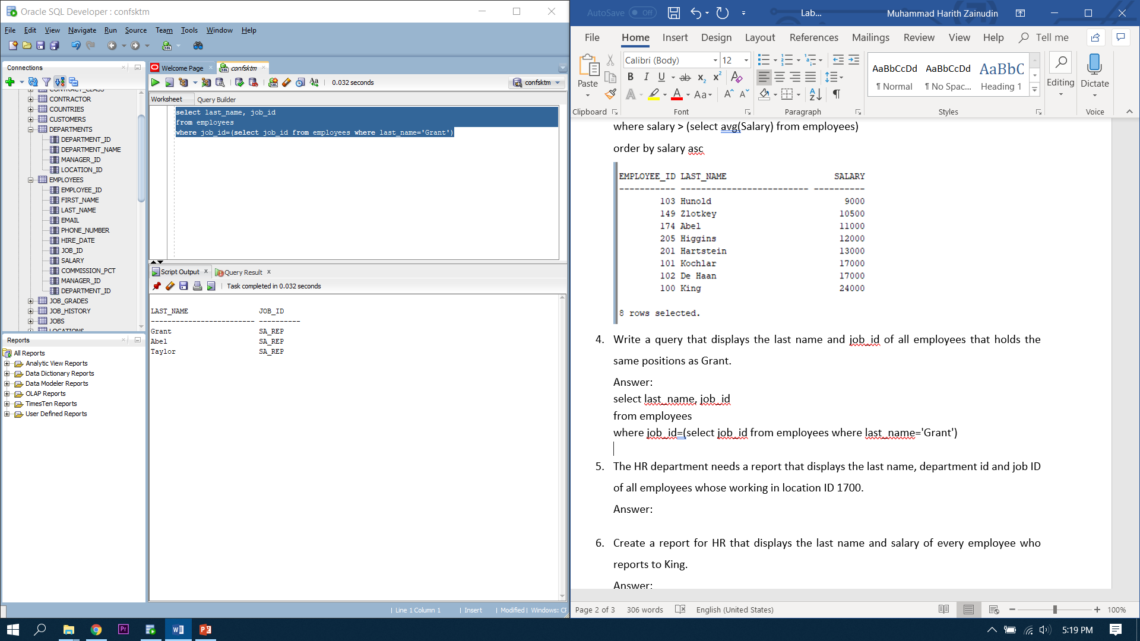

1. The HR department needs a report that displays the last name, department id and job ID of all employees whose working in location ID 1700.

Answer:

*select last_name, department_id, job_id*

*from employees*

*where department_id in (select department_id from departments where location_id='1700')*

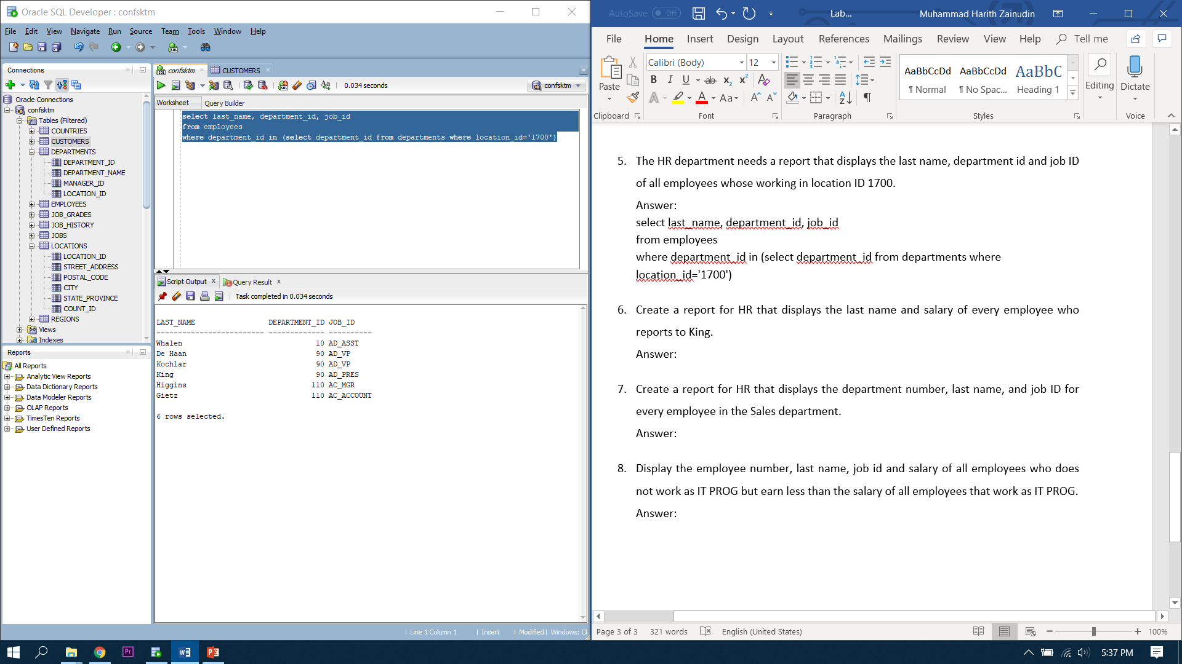

1. Create a report for HR that displays the last name and salary of every employee who reports to King.

**Answer:**

*select last_name, salary*

*from employees*

*where manager_id = (select employee_id from employees where last_name= 'King')*

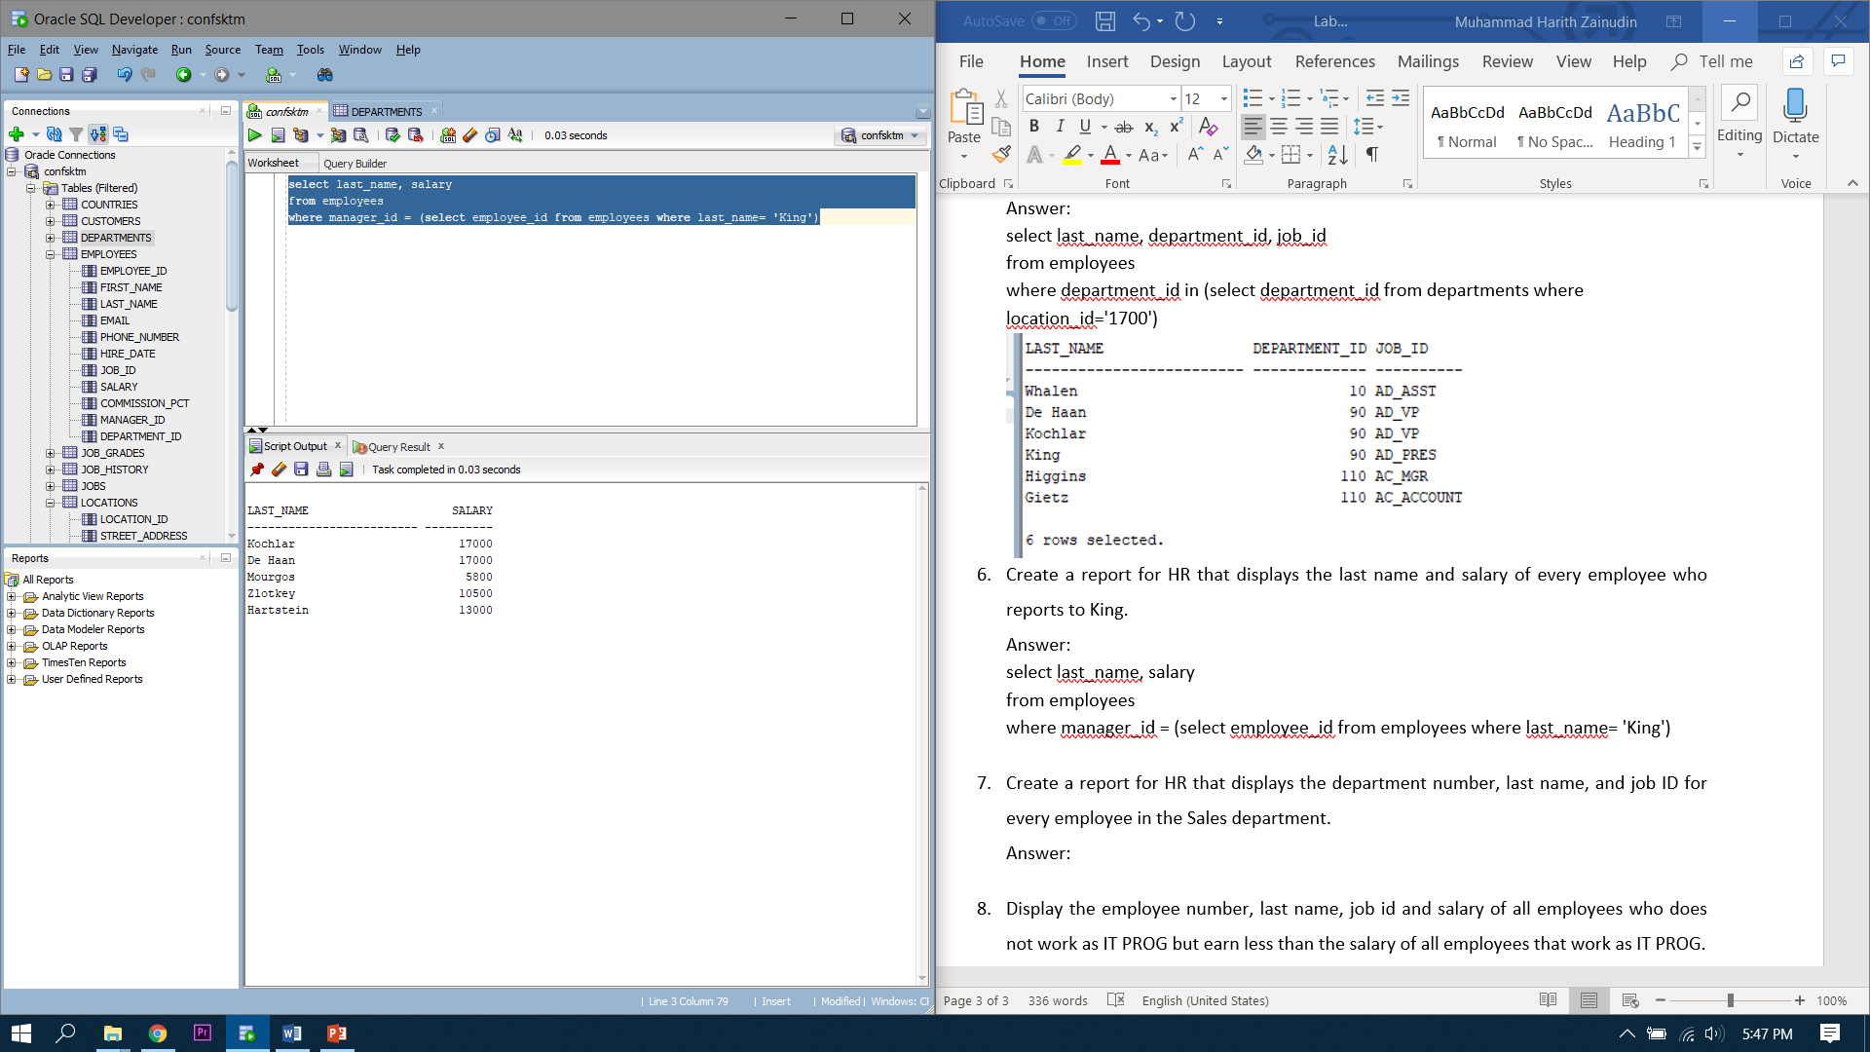

1. Create a report for HR that displays the department number, last name, and job ID for every employee in the Sales department.

***Answer:***

*select department_id, last_name, job_id*

*from employees*

*where department_id = (select department_id from departments where department_name='Sales')*



1. Display the employee number, last name, job id and salary of all employees who does not work as IT PROG but earn less than the salary of all employees that work as IT PROG.

**Answer:**

*select employee_id, last_name, job_id, salary*

*from employees*

*where job_id not in ('IT_PROG') and salary < (select min(salary) from employees where job_id like 'IT_PROG')*

